**A Review of Image processing techniques for Augmented 3D modeling**

**Abhijeetsinh Vaghela1, Nihar Patel2, Tanay Tewar 3, Vinita Shah 4**

1Research Scholar, G H Patel College of Engineering and Technology, Vallabh Vidyanagar, Gujarat, India

abhijeet201998@gmail.com

2 Research Scholar, G H Patel College of Engineering and Technology, Vallabh Vidyanagar, Gujarat, India

niharjnpatel@gmail.com

3 Research Scholar, G H Patel College of Engineering and Technology, Vallabh Vidyanagar, Gujarat, India

tanaytewar4@gmail.com

4 Assistant Professor, G H Patel College of Engineering and Technology, Vallabh Vidyanagar, Gujarat, India

vinitashah@gcet.ac.in

**ABSTRACT**

This survey attempts to provide a brief overview of morphological operations and image segmentation for image processing.  It aims at exploring methods involved in generating a dynamic 3D model using architectural house plans. It also aims at understanding different methods that can be used to optimize the 3D output.

**Keywords:**  Dynamic 3D modeling, Augmented-reality, Image processing

1. **INTRODUCTION**

Two-Dimensional(2D) house plans are incompetent in the sense that the client/end user may not be able to properly visualize the layout. To a layman’s eye, a floor plan is understandable only to a certain extent if the dimensions are laid out in 2D. The untrained eye finds it hard to understand how a 2D layout would look in real life.

The first feasible solution that generally comes up with the occurrence of such a problem is the use of CAD software. But this solution comes with the overhead of hiring a CAD specialist. Another solution is to make an actual physical model, but it demands lots of man-hours and money. In addition to that, it lacks the feature of being dynamic i.e. further changes cannot be done. There are online tools available which assist user visualization but the input needs to be redrawn every time making the process tedious. We aim at overcoming these issues by combining all the positive aspects of the above-mentioned methods into a single application. We aim at giving the user the power to convert the layout into 3D efficiently and as per their convenience and need.

One of the most effective solutions found was to dilate the initial image first so that all the unwanted text is removed. Next, the corners and edges should be detected. Then using template matching, color extraction should be done. The output files of corner-edge detection and color extraction should be combined to obtain an accurate three-dimensional visualization.

1. **RELATED WORKS**

In “Morphological Operations for Image Processing” [1], Ravi Shrisa and Am Khan, have made an attempt to understand the basics of all morphological operations and used MATLAB software to run tests. They have described Dilation as a morphological operation that adds pixels to the boundary pixels. Erosion of an image with a structuring element causes the boundary pixels to shrink in size. While opening and closing are the operations that are a combination of dilation and erosion. Here, they have used images with a black background and with structural element, hence erosion causes the boundary pixels to shrink in size. But if we use an image with white background and black structural element, dilation is the operation which causes the boundary pixels to shrink in size.

In “Methodological Survey and Proposed algorithm on Image Segmentation using genetic algorithm” [2], M.Agarwal and V.Singh, have provided a brief overview of some of the most common image segmentation techniques. They have discussed different Edge Detection techniques namely Prewitt edge detector, Sobel edge detector, Canny edge detector, Roberts edge detector, Laplacian edge detector. The most commonly used techniques are Robert’s, Sobel and Prewitt’s edge detector [7]. The Roberts Cross [6] operator performs a simple, quick to compute, 2-D spatial gradient measurement on an image. It is mainly used when diagonal edges are of main interest. The Prewitt edge detector [6] estimates the magnitude and orientation of an edge. It is limited to 8 possible orientations and each orientation is a 3X3 neighborhood mask. The Sobel edge detection operator is a discrete differentiation operator, it has better noise suppression feature that makes it preferable over Prewitt operator.

In [2], the authors have mentioned that among existing methods, Canny edge detector is comparatively better. The Laplacian is usually used to establish whether a pixel is on the dark or light side of an edge. The Canny edge detector is an optimal edge detector algorithm that marks as many actual edges as possible and an actual edge is marked only once. Canny technique to find edges does not create false edges due to the presence of noise i.e. it isolates noise [6] from the image before finding the edges, without affecting the features of the edges. Frei and Chen [8] suggest that edge detection is best carried out by a simple edge detector, followed by a morphological thinning and linking process to optimize the boundaries.

In “Shape Matching and Object Recognition using shape contexts” [3], S. Belongie, J. Malik, and J. Puzicha, have proposed a new approach towards shape matching has been presented by the author. The main focus of this approach is the estimation of shape similarity and correspondences based on a novel descriptor, the shape context.  The shape context at a reference point captures the distribution of the remaining points relative to it. This approach provides a reach descriptor for point sets that greatly improves point set recognition.  Invariance to several common image transformations, including significant 3D rotations of real-world objects has been exhibited in the experiments.

In “An FPGA-based accelerator for multiple real-time template matching” [4], authors have discussed ZNCC based template matching. Template matching is an image processing technique to looking for areas of a source image that match to a template image. The search consists in sliding a template image over a source image and calculates a similarity measure between the template and each image window. The Result matrix (R) numerically represents how well the template matches in each image position. The Zero Mean Normalized Cross Correlation (ZNCC) is a similarity measure that presents as an advantage the robustness against the linear intensity distortions and image contrast variations. The computation of ZNCC could be accelerated using fast Fourier transform (FFT) and integral images or using multiresolution search. Therefore, by ZNCC based template matching, windows, doors etc. can be easily identified in-house plans based on predefined templates.

In “A Survey of Augmented Reality” [9], R.T. Azuma, states that besides adding objects to a real environment, Augmented Reality also has the potential to remove them. Graphic overlays might also be used to remove or hide parts of the real environment from a user. For example, to remove a desk in the real environment, draw a representation of the real walls and floors behind the desk and "paint" that over the real desk, effectively removing it from the user's sight. Gloves with devices that provide tactile feedback might augment real forces in the environment. For example, a user might run his hand over the surface of a real desk. Then the tactile effectors in the glove can augment the feel of the desk, perhaps making it feel rough in certain spots. This capability might be useful in some applications, such as providing an additional cue that a virtual object is at a particular location on a real desk. The display devices used in AR may have less stringent requirements than VR systems demand, again because AR does not replace the real world. For example, monochrome displays may be adequate for some AR applications, while virtually all VR systems today use full color.

1. **METHODS AND TECHNIQUES**
   1. **Morphing**

Morphological operations are simple to use and work on the basis of set theory. The objective of using morphological operations is to remove imperfections in the structure of the image. The basic morphological operations are dilations and erosion and opening and closing are other operations which are performed using dilation and erosion.

1. **Dilation**

The dilation operation makes an object grow by size. The extent to which it grows depends on the nature and shape of the structuring element [1]. The dilation of an image A (set) by structuring element B is defined as:

A ⊕ B = $\left\{z | (B)z ∩ A ≠ ∅\right\}$

Dilation process is basically used to fill the holes (missing pixels) in a continuous object. The dilation process adds pixels to the boundary hence, blurring effect can be observed. So, it is like a smoothing spatial low pass filter [1].

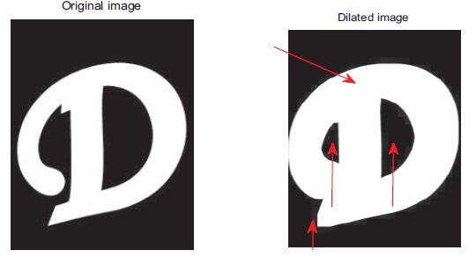

1. **Erosion**

The erosion operation is the inverse of dilation in the context of the effect of the operation. It causes the object to lose its size [1]. Erosion of an image A by structuring element B is defined as:

A Ө B = $\left\{z | \left(B\right)z ⊆A\right\}$

Erosion removes those structures which are smaller than the structuring element. So, it can be used to remove the noisy connection between two objects. As the unwanted pixels are erased, the final effect is the sharpening of the object [1].

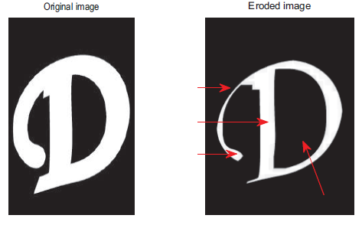

1. **Opening**

Opening of an image is a combination of erosion and dilation [1]. The opening of an image A by structuring element B is defined as:

A o B = (A Ө B) ⊕ B

Opening operation smoothens the outline of an object clears narrow bridges and also eliminates minor extensions present in the object.

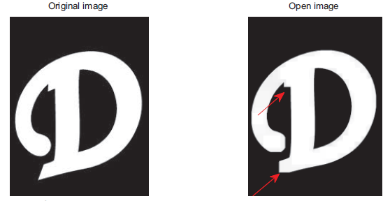

1. **Closing**

Closing of an image is also a combination of erosion and dilation. It only differs from opening in the order of occurrence of erosion and dilation [1]. The closing of an image A by structuring element B is defined as:

A ⋅ B = (A ⊕ B) Ө B

The closing operation smoothens sections of contours it in general blends narrow breaks and thin gaps. So, it eliminates small holes and fills gaps in the object boundaries.

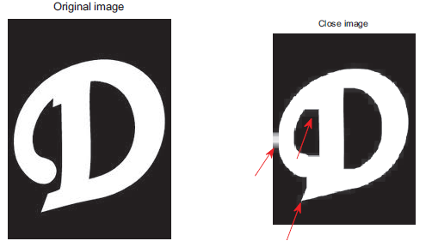

* 1. **Image Segmentation**

1. **Prewitt edge detector**

The Prewitt edge detector [6] is a discrete differentiation operator, computing approximate gradient of image intensity function. It estimates the magnitude and orientation of an edge. It is limited to 8 possible orientations and each orientation has a 3X3 neighborhood mask. Hence, the result of Prewitt operator shows how abruptly or smoothly the image changes at that point.

1. **Sobel edge detector**

Sobel operator is similar to Prewitt operator, it is also a discrete differentiation operator. It also uses 3X3 kernels, just like Prewitt operator. The Sobel operator [6] represents a rather inaccurate approximation of the image gradient but is still of enough quality to be of practical use in many applications. Sobel operator has better noise suppression which makes it preferable to the Prewitt operator.

1. **Roberts Cross edge detector**

The Roberts cross operator is a differential operator. It was one of the first edge detectors. It obtains the approximate gradient of an image through discrete differentiation which is achieved by computing the sum of squares of the differences between diagonally adjacent pixels. Roberts proposed the following equations:

y(i,j)=

z(i,j)= $$\sqrt{(\left(y\left(i,j\right)-y\left(i+1,j+1\right)\right)2+((y\left(i+1,j\right)-y\left(i,j+1\right))2}$$

1. **Canny edge detector**

The Canny edge detector uses a multi-stage algorithm to detect a wide range of edges in images. The process of Canny edge detection can be broken down to 5 different steps:

1. Apply Gaussian filter to smooth the image to remove the noise.
2. Find the intensity gradients of the image.
3. Apply non-maximum suppression to get rid of spurious response to edge detection.
4. Apply double threshold to determine potential edges.
5. Track edge by hysteresis: Finalize the detection of edges by suppressing all the other edges that are weak and not connected to strong edges.

Hence due to this elaborate procedure, Canny edge detector gives the best results.



Above figure shows the results of Sobel, Roberts, Prewitt, Laplacian and Canny edge detection performed on a satellite image of Saturn [6].

1. **CONCLUSION**

The main intention behind writing this paper to study various researches for an optimal output. After analyzing various papers, we concluded that Canny EDGE DETECTION gives the most optimal output for image segmentation compared to other available methods. Also, among morphological operations Erosion has proved to be the most ideal.

1. **REFERENCES**
2. Ravi Srisha and Am Khan, “Morphological Operations for Image Processing: Understanding and its Applications”, Dec. 2013. Accessed: Sept. 16, 2018.
3. M. Agarwal and V. Singh, "A methodological survey and proposed algorithm on image segmentation using genetic algorithm," International Journal of Computer Applications, vol. 67, no. 16, pp. 17–7, Apr. 2013. Accessed: August 10, 2018.
4. S. Belongie, J. Malik, and J. Puzicha, "Shape matching and object recognition using shape contexts," IEEE Transactions on Pattern Analysis and Machine Intelligence, vol. 24, no. 4, pp. 509–522, Jan. 2002. Accessed: May 22, 2018.
5. E. S. Albuquerque, Antonyus P. A. Ferreira, João G. M. Silva, João P. F Barbosa, Renato L. M. Carlos, Djeefther S. Albuquerque, Edna N. S. Barros, "An FPGA-based accelerator for multiple real-time template matching," pp. 1–6, Aug. 2016. Accessed: Apr. 12, 2018.
6. Arif Mahmood and Sohaib Khan. “Correlation-coefficient-based fast template matching through partial elimination”. Image Processing, IEEE Transactions on, 21(4):2099–2108, 2012.
7. Mr. Salem Saleh Al-Amri, Dr. N.V. Kalyankar and Dr. Khamitkar S.D, “Image Segmentation By Using Edge Detection”, (IJCSE) International Journal on Computer Science and Engineering Vol. 02, No. 03, 2010, 804-807.
8. N. Senthilkumaran, R. Rajesh. “Edge Detection Techniques for Image Segmentation - A Survey”, Proceedings of the International Conference on Managing Next Generation Software Applications (MNGSA-08), 2008, pp.749-760.
9. W. Frei, C. Chen, "Fast Boundary Detection: A Generalization and New Algorithm," IEEE Trans. Computers, vol. C-26, no. 10, pp. 988-998, Oct. 1977.
10. R. T. Azuma, "A survey of augmented reality," Presence: Teleoperators and Virtual Environments, vol. 6, no. 4, pp. 355–385, Aug. 1997.